Steps to success - Short multiplication: No exchanging.
- First set up the numbers in the correct columns. Always put the 2-digit number at the top.  So: 31 x 3 =  Would look like this: T O  3 1  X 3  Remember, 1 number in each square. | 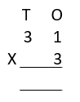  - Next, multiply the top number in the ones column by the bottom number in the ones column.  1 x 3 = 3  Put the answer underneath.
- Then, multiply the number in the tens column by the bottom number in the ones column.  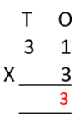  3 x 3 = 9  This tells us that 3 lots of 3 tens make 9 tens. | - Put the answer between the equals in the tens column and you’re done!  31 x 3 = 93

