
Date: ____________________________
Year 5 Design & Technology Autumn Knowledge Quiz: Cooking and Nutrition (Making A Greek Flatbread)
 | Question | Answer A | Answer B | Answer C | / 
1 | Which of these ingredients is not a herb? | 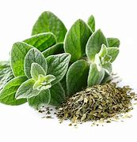  oregano | 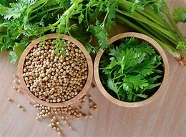  coriander | 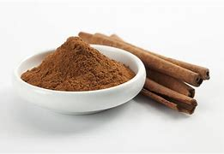  cinnamon
2 | What skill do you need to make your dough? | 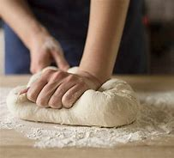  kneading dough | 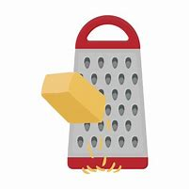  grating | 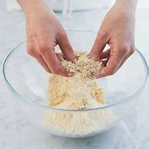  rubbing in
3 | If you make your flatbread in your kitchen today and want to save it and eat it a week later, how would you store it? | 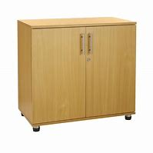  in the cupboard | 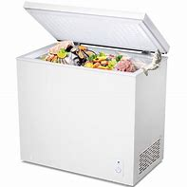  freezer | 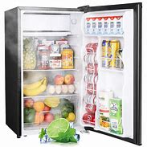  fridge
4 | What food would the ancient Greeks not have eaten? | 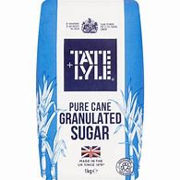  sugar | 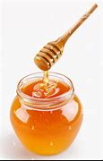  honey | 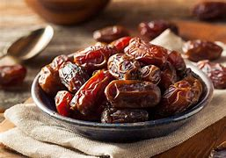  dates
5 | What should you do if you cut your finger in the process of preparing ingredients for your flatbread? | Lick it clean. | Clean cut and apply a plaster and, if necessary, cover hand with a plastic glove. | Wrap a paper towel around it.
 |  |  |  | Total

