 | Autumn |  | Spring |  | Summer
Nursery | Me – Baby to Now  Toys we play with  My Family  Our Nursery Community |  | Occupations |  |  | How we have grown
Reception | All about Me  Families – Similarities and Differences | Our School Community  School in the Past
Year 1 |  | Toys |  | George Stephenson |  | The Great Fire of London
Year 2 | Captain James Cook |  | Our School  (Local study) |  | Nurses and healthcare
Year 3 |  |  | Stone Age to Iron Age Britain |  |  | The Romans
Year 4 |  |  | Earliest civilisation and Ancient Egypt |  |  | Industrial Revolution  (Local study)
Year 5 | Ancient Greece |  | Anglo-Saxons/ Scots/ Vikings
Year 6 | World War II |  |  |  | Mayan Civilisation

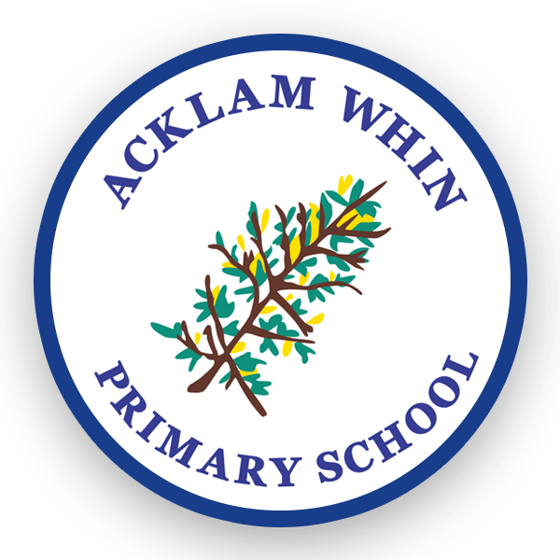
History Curriculum Overview

