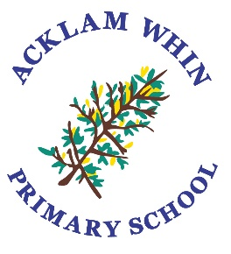

Acklam Whin Primary School

Behaviour Policy

Approved by Governors: March 2022
Reviewed in: March 2025

To be Reviewed: March 2026

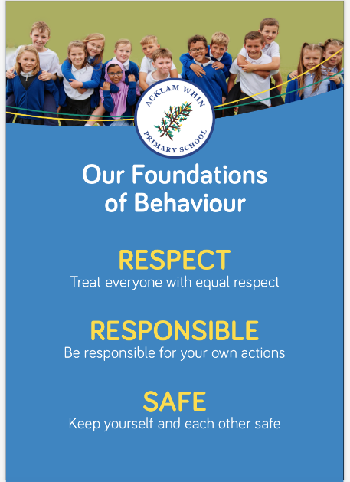

Rationale:
We aim to create a calm, caring and safe environment, where relationships are based on respect and to develop a positive sense of self-discipline in which every child is responsible for their own actions. We believe that being attachment-aware and implementing trauma-informed practice supports emotional regulation, trust and positive relationships.

Foundations of Behaviour
Staff and all stakeholders refer to the Foundations of Behaviour and reinforce them through praise and rewards.

Our school focus is on positive behaviour and attitudes which we celebrate through acknowledging good choices.

Our Acklam Whin Core Values are Aspirational, Caring, Creative, Curious, Independent, Positive and Resilient. They are celebrated each week in our whole school assembly. Children who demonstrate one of these values consistently will receive a certificate acknowledging their success. Their goal is to achieve all seven values as they progress through school.

Each child is a member of an Animal Team, led by their Year 6 Team Captains. Adults award points for positive behaviour and attitudes which contribute to the success of their team. The points totals are celebrated each week in assembly and the team with the most weekly wins at the end of each term receive a reward. Pupil Voice and School Council members suggest ideas for the reward.
Staff
We believe that all members of staff are entitled to work in a safe, non-threatening environment and should be treated with politeness and respect. Staff will model positive behaviours and have high expectations of all our children in and around school.

Parents/Carers

At Acklam Whin Primary School we ask that parents/carers:

- Support our Foundations of Behaviour
- Let the school know about any concerns or problems that might affect their child’s behaviour
- Work with staff in managing and addressing their child’s behaviours.

We work in partnership with parents/carers and will offer support and guidance. We follow a graduated response to best meet the individual needs of each child through the involvement of the school team and, where appropriate, external agencies.
Monitoring Behaviour in School

Where there is cause for concern, written notes will be kept in the internal reporting system CPOMS.
Our strategy to support positive behaviour choices

Our inclusive approach scaffolds a child to self-regulate and adaptations are put in place to support children in making the right choices. Early intervention, with ELSA support, resources and strategies shared with staff and parents.

At Acklam Whin Primary School we teach children what is acceptable behaviour. If a child’s behaviour is inappropriate, it is important that a clear, consistent approach is taken.

Stage 1 – Intervention by a member of staff

- Outlining the unacceptable nature of the behaviour, through referring to our Foundations of Behaviour
- Explaining the effect that the behaviour is having on the child and others through the use of a restorative conversation
- Providing the child with an example of an alternative, positive way of behaving

If a child persists with the unacceptable behaviour the following approach is applied:
Stage 2 – Reflection & Reparation in class

- Reinforcing the unacceptable nature of the behaviour and explain to the child that they will work in a different area of the classroom to support them in making the right choices.

Stage 3 - Reflection & Reparation in the other class of same year group
- Reinforcing the unacceptable nature of the behaviour and explain to the child that they will be working in the other class in the same year group.

Stage 4 - Reflection & Reparation in the other class of different year group
- Reinforcing the unacceptable nature of the behaviour and explain to the child that they will be working in another year group.
Children will be sent to the following partner year groups
Reception to Nursery
Year 1 to Year 2
Year 2 to Year 1
Year 3 to Year 5
Year 4 to Year 6
Year 5 to Year 3
Year 6 to Year 4

- Follow up discussion with class teacher/phase lead and recorded on CPOMS.
- Class teacher or phase lead will inform parent about the incident.

Stage 5 - Reflection & Reparation with phase lead/member of SLT
- Reinforcing the unacceptable nature of the behaviour and explain to the child that they will be working with the member of SLT
- If behaviour persists, regular contact with parents/carers will continue.
- If no improvement is evident, a formal meeting involving parents, class teacher and a member of SLT will take place to discuss strategies to support the child and their behaviour.
- Involvement of external agencies, where appropriate

At times, according to the severity of the behaviour it may be necessary for some of the stages to be omitted.

At times, it will be necessary to adapt this policy to reflect a child’s individual needs. Some children, where required, will have an individual behaviour plan which reflects their personalised needs.

Reflection & Reparation at playtime

- Outlining the unacceptable nature of the behaviour, through referring to our Foundations of Behaviour
Explaining the effect that the behaviour is having on the child and others through the use of a restorative conversation
Providing the child with an example of an alternative, positive way of behaving
- A specified amount of reflective time-out at playtime and inform class teacher.
- If the incident was of a serious nature, SLT would be informed, and the child would spend some time with a member of SLT and parents would be informed.

Anti-Bullying Policy

This policy should be read alongside and in conjunction with our Anti Bullying Policy.

