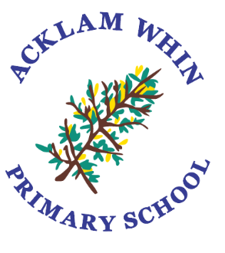

SEND Information Report
2025-2026
SENDCo – Miss Tarran

Effective from: September 2025
Date to be reviewed: September 2026

www.acklamwhin.co.uk
Identification of Needs
At Acklam Whin, we have a number of strategies for identifying Special Educational Needs and fully involve parents at every stage.
- Class teachers monitor children’s progress and achievement closely and will liaise with a member of the inclusion team should there be a change in or concern regarding a pupil’s progress or behaviour.
- Termly pupil progress reviews use assessment data and staff knowledge to track the progress of all children and discuss where additional support is needed.
- Parents/carers or children may raise concerns with a member of staff.
- The class teacher is the initial point of contact for responding to parental concerns.
- Parents are also welcome to discuss concerns with a member of the inclusion team
Miss Tarran | Special Educational Needs Disabilities Co-ordinator (SENDCo) Designated Safeguarding Lead (DSL)
Mrs Prince | Head Teacher – Deputy Designated Safeguarding Lead (DDSL)
Mrs Wilson | Key Stage 2 Leader, attendance and DDSL
Mrs Ingledew | Key Stage 1 Leader
Miss Mills | Early Years Foundation Stage Leader
Mrs Tribe | Social, Emotional and Mental Health (SEMH) and SEND support
Mrs Ward  Mrs Trodden | Speech and Language support

- The SENDCo, Miss Tarran, oversees the overall monitoring and evaluation systems in place for progress and provision for all children on the SEND register and adopts a graduated response.
- Our head teacher, Mrs Prince, has the overall responsibility for all aspects of school including the support for pupil with special educational needs and disabilities.
- We have a designated SEND governor, Mrs Butchart, whose responsibilities include:
- supporting the team in carrying out their work to a high standard;
- promoting high expectations;
- monitoring and evaluating the quality of teaching, learning, attainment and progress;
- ensuring that SEND allocation in the budget enables, as far as possible, the team to meet its objectives and by doing so raise standards in the classroom;
- ensuring commonality of practice in line with school policy.

Four Broad Areas of SEND

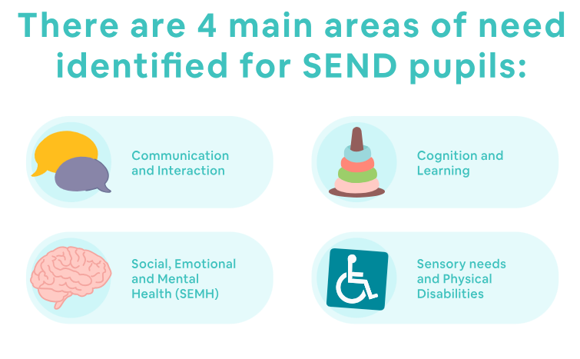

Communication and Interaction
This includes children with speech and language delay, impairments or disorders, specific learning difficulties such as dyslexia, hearing impairment, and those who demonstrate features within the autistic spectrum.
Cognition and Learning
This includes children who demonstrate features of moderate, severe or profound learning difficulties or specific learning difficulties
Social, Mental and Emotional Health
This includes children who may be withdrawn or isolated, disruptive, hyperactive or lack concentration.
Sensory and/or Physical
This includes children with sensory, multi-sensory and physical difficulties.
Support
At Acklam Whin, all children are taught a broad and balanced curriculum through quality first teaching. Where children require extra support, resources or adapted materials this will be provided wherever possible.

- In class provision will be organised and provided by the class teacher through:
- Quality first teaching;
- careful planning which takes into account the needs of all the children;
- strategic help, with the teacher targeting tasks for children who need more input or guidance;
- work which is appropriately matched to the individual need and taught through an arrangement of different groups, tasks or resources;
- arranging additional small group or 1:1 intervention work to target a specific area of need;
- monitoring and evaluating the effectiveness of the provision for all children and adjusting provision accordingly;
- creating a SEND support plan for the pupil which sets achievable targets and details strategies and support in place for progress to be made towards achieving them.
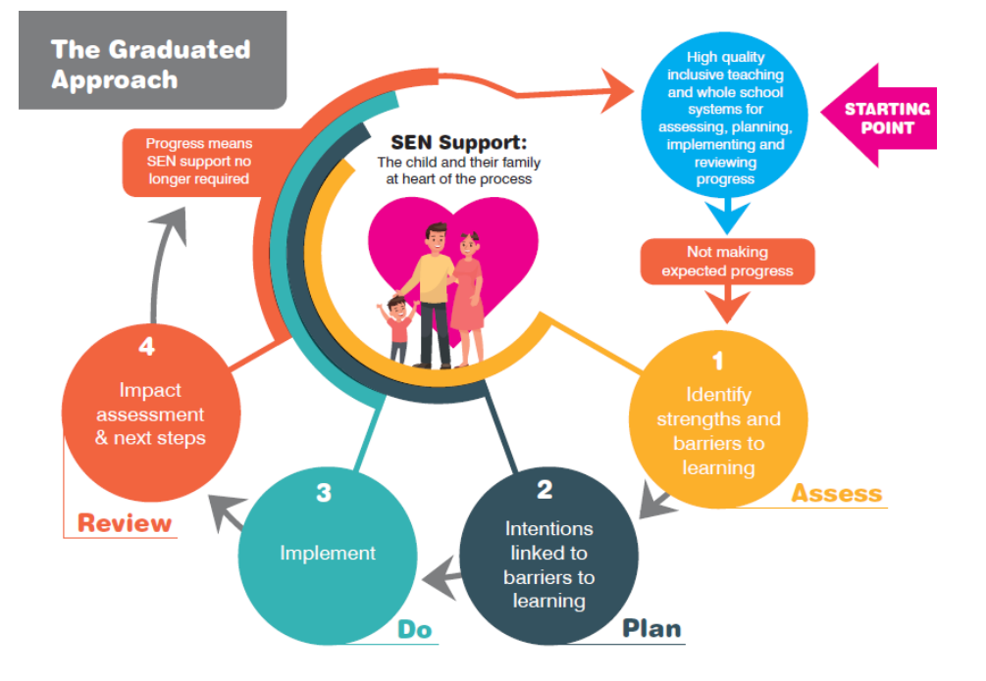
We follow a graduated response approach:

At Acklam Whin, we carefully organise the type of provision to match each pupil’s individual needs.
- We follow a graduated approach to meeting the pupil’s needs. This will be through the adoption of a four-part cycle – assess, plan, do, review. The process is as follows:
  - Assess: establishing a clear assessment of the pupil’s needs
  - Plan: agreeing the adjustments, interventions and support to be put in place, as well as the expected impact on progress, development or behaviour, along with a clear date for review
  - Do: implementing the agreed interventions and support
  - Review: analysing the effectiveness of the interventions and their impact on the pupil’s progress in line with the agreed review date
- Class teachers will create a SEND support plan for the pupil which sets achievable, short-term targets and details strategies and support in place for progress to be made towards achieving them. This will involve details of classroom strategies and may also involve the pupil working in a 1:1 or small group for a defined period of time. Information from external agencies, can also inform the SEND support plan.
- Parents/carers and children (where appropriate) are actively encouraged to support the progress towards these targets both at home and at school and are involved in a termly review of the targets identified in the SEND support plan. During these meetings, progress towards these targets is discussed with the class teacher.
- Where children are working in a 1:1 or small group intervention, targets will be identified on our school’s tracking system which will enable all staff to clearly review progress made and inform future planning.
- Termly pupil progress reviews use assessment data and staff knowledge to track the progress of all children and discuss where additional support is needed.
- In some cases, referrals will be made, with parent/carer consent, to external agencies or specialist provision for additional assessment or support.
- Some children may require an Educational Health Care Plan (EHCP) which will detail further support and provision to put in place by the school. These plans are put in place if a significant special educational need or disability is identified by a multidisciplinary panel.
Curriculum
At Acklam Whin, all children are taught a broad and balanced curriculum through quality first teaching. Where children require extra support, resources or adapted materials this will be provided wherever possible for example:
- careful planning, ensuring targeted resources, adaptations and scaffolding to meet the needs of all children
- 1:1 or small group focused work, as appropriate
- specialist equipment will be provided if appropriate e.g. sloping boards, wobble/wedge cushions, specific pens etc.
- a SEND support plan will be put in place detailing specific strategies and support
Accessibility
Acklam Whin is a fully accessible school.
- Class allocations can be adapted to ensure rooms are accessible for children with additional needs e.g. hearing or visual impairments and we are happy to discuss any pupil’s specific additional requirements. Our school has disabled access and toilet facilities available.
- Please see Acklam Whin’s accessibility plan for further details.
- Clear communication is a key factor in building effective relationships with parents/carers. If appropriate, our school could arrange for an interpreter to support parents in their involvement in home-school communication when necessary.

Parental Involvement
At Acklam Whin we endeavour to build excellent home-school relationships and fully involve parents/carers in the learning, progress and well-being of every child.
- Class teachers and teaching assistants are available on a regular basis for informal communication regarding a pupil’s progress and well-being. Appointments can always be made to discuss issues in more depth at an appropriate time.
- Termly parents’ consultations are held which provide a focused opportunity for parents/carers and class teachers to discuss a pupil’s progress and well-being as well as review their SEND support plan and discuss support and provision.
- Class teachers may provide strategies which can be used by parents/carers to support their child’s progress at home. In some cases, these strategies may have been suggested by external support agencies such as an Education Psychologist, Speech and Language etc.
- At any time, parents/carers are welcome to make an appointment to discuss their child’s progress and well-being with an appropriate member of our inclusion team.
- Parents/carers are also fully involved in the support of any external specialists such as Speech and Language, Educational Psychologists etc. A member of our inclusion team acts as the key point of contact between all stakeholders in these cases.
- Any reports or assessments which have been produced by an external agency is shared directly with parents/carers either by the professionals who created the report or by the class teacher or SENDCo.
- SEND information sessions led by school and external specialists regularly take place with a focus e.g. Autism, S&L, Social Stories.
Overall Wellbeing
At Acklam Whin we pride ourselves on ensuring the well-being of all of our children.
Social, emotional well-being
- Class teachers and other adults working within year group teams provide daily, ongoing pastoral support and developing the well-being of the whole child is strongly embedded within our curriculum and ethos.
- For children with specific emotional or social needs, targeted support at school level or external agency level can be discussed and arranged via class teachers or a member of the inclusion team.
- Our school also has access to specialist services which can provide social and emotional support for both children and families. Working alongside parents/carers, a referral can be made through school if deemed appropriate.
Medical
- When necessary and in agreement with parents/carers, trained staff can administer medicines within school and careful monitoring systems are in place to do so effectively to safeguard both children and staff. Please see our Medicines Policy for further information.
- For children with specific medical requirements a Health Care Plan can be written in conjunction with medical professionals and parents/carers to ensure that the specific needs of the pupil are met effectively.
- We have a wide range of staff who are first aid trained, and this training is regularly updated.
- High quality training is undertaken by all relevant staff to ensure that children with specific needs are safeguarded. Training such as EpiPen use, epilepsy and asthma awareness is delivered by an appropriate professional and agreed systems and policies are shared with all staff.
- The school nurse or health visitor (for children in Nursery) is available to offer advice and support to both staff and parents/carers.

Specialist Services
At Acklam Whin, the SENDCo or appropriate member of the inclusion team will organise the support of specialist services either within school or from outside agencies if deemed appropriate. These may include:
- Educational Psychologist
- Speech and Language
- LA Outreach and Inclusion
- Occupational Therapy
- Physiotherapists
- Child and Adolescent Mental Health Service (CAMHS)
- The Bungalow Partnership
- The Junction Foundation Therapy
- Head Start
- Forget Me Not – bereavement support
- Hearing Impaired Service
- Children’s Service for the Visually Impaired
- Outreach support from specialist provisions including - The Early Years Support Service, Beverley School, Holmwood School
- School Nurse / Health Visitor
Parents/carers are fully informed about any assessment outcomes or programmes of support that are put in place. Strategies to support their child’s need at home will also be shared and supported by school.
Activities outside of school
- We have a range of extra-curricular activities which all children are welcome to and encouraged to participate in. Any specific needs can be discussed with the member of staff leading the activity. For further details, please speak to your child’s class teacher.
- All children have access to educational visits throughout the year to enrich our broad and balanced curriculum. Risk assessments are carried out by key members of staff prior to any visit and then discussed with our school’s educational visits co-ordinator: Miss Appleby. The specific needs of any child will be discussed with parents/carers to ensure their full access and enjoyment of any educational visit. Obviously, the safety of children and staff is paramount and will be considered prior to any educational visit or extra-curricular activity.
Staff CPD Training
Professional development for all staff at Acklam Whin is an ongoing priority and all staff are expected to ensure their continual development in all areas including supporting children with SEND. In addition to regular whole staff training and development, specific training is identified as need arises. This is aimed at relevant staff members with an expectation that they share their learning to support the development of others.
Transition
At Acklam Whin, we understand the importance of smooth transitions and have a number of systems in place as children move through our school.
- Ongoing dialogue between class teachers and support staff.
- Regular meetings with parents/carers to ensure that they are fully informed at each stage of their child’s progress through school.
- Where appropriate, transition meetings with parents/carers, current and new class teachers can be arranged. The SENDCo or appropriate member of the inclusion team can also attend this meeting if necessary.
- In the summer term, current class teachers meet with new class teachers in order to discuss support and provision for the following year to ensure smooth transition into the next year group in terms of progress and well-being.
- Transition work and class change overs support the familiarisation of children with their new class, staff and area of school.
- Additional transition is provided for identified children.
In certain areas of school, other strategies are also in place:
Early Years Foundation Stage (EYFS)
- Parents’ meeting to provide an opportunity for parents/carers to find out more about EYFS, ask questions and familiarise themselves with the staff and environment.
- Regular transition visits to school throughout the summer term to help children to become more familiar with the environment and staff.
- Nursery children are also invited to have a school lunch as part of their transition into Reception.
- Any children joining our school who have not attended Acklam Whin Nursery are also invited to take part in these transition activities. Any additional transition that is deemed necessary can be organised by contacting our EYFS leader, Miss Mills or, in the case of a pupil with a SEND need, our SENDCo, Miss Tarran.
Y6 Transition to Secondary School
- For all children, transition meetings are held with staff from the new secondary school.
- Transition days provide the opportunity to experience their new school and familiarise themselves with the staff and surroundings.
- We develop close links with our secondary school and ensure clear communication regarding the transition of our children.
For children with SEND:
- Additional visits can be organised via the SENDCo or Y6 class teacher
- Transition meetings with Acklam Whin’s SENDCo, Secondary SENDCo, Y6 teacher, parents/carers and children can be held to discuss the child’s individual needs and provision.
- Transition information is passed onto the receiving school detailing key information e.g. the child’s SEND support plan, any additional assessment information, key findings from reports from external agencies etc.
- The parents/carers of any child who has an Educational Health Care Plan is involved in discussion regarding their child’s secondary placement as part of their Y5 Annual Review. Once a secondary school has been chosen and a place allocated, the school SENDCo acts as a liaison between all stakeholders to ensure smooth transition.

New arrivals
- Parents/carers and children are encouraged to arrange a visit to our school prior to starting at Acklam Whin to familiarise themselves with the surroundings and meet key staff.
- Close liaison takes place between our school and the child’s previous school. This may include staff from Acklam Whin visiting the child in their current setting and also speaking with their class teacher and SENDCo regarding their achievement, progress, well-being and current support.
- Class teachers will be readily available to support new children and parents/carers to ensure smooth transition and will employ strategies such as a ‘buddy system’ to help newcomers settle into school routines.
- Our school SENDCo, or appropriate member of the inclusion team will always be happy to arrange a meeting with new parents/carers and children to discuss and support transition.
SEND Resources
At Acklam Whin resources are allocated and matched to the pupil’s special educational needs. These may include:
- additional resources and specialist equipment e.g. sloping writing boards, computer software, intervention support programs
- 1:1 or small group targeted support for a clearly defined period of time focusing on specific targets
- additional in class support to target specific needs

- Additional resources decisions are made based upon pupil progress and need as it arises. These decisions can be made:
- within teaching teams by class teachers and phase leaders
- as a result of pupil progress reviews with teaching teams
- in liaison with an appropriate member of the inclusion team
- as a results of assessment and support strategies suggested by external agencies e.g. an educational psychologist
How to contact us
The class teacher is always the first point of contact for parents/carers regarding their child’s progress and well-being.

Members of the inclusion team can be contacted via the school office or by phoning 01642 813938

Miss Tarran – Special Educational Needs Co-ordinator (SENDCo) - awcontact@acklamwhin.co.uk

Other useful contacts
The Local Authority’s Local Offer website provides information and advice about services for children with special educational needs and disabilities and their families in Middlesbrough. This can be accessed at www.middlesbrough.gov.uk/localoffer

Middlesbrough LA 0-25 SEN team 01642 201828
Stockton LA 0-25 SEN team 01642 524813

Complaints
Please follow the complaints policy. Which is accessible on the school website. www.acklamwhin.co.uk
