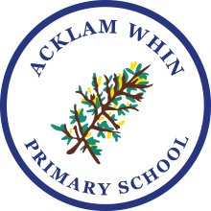

Reception Parent Handbook
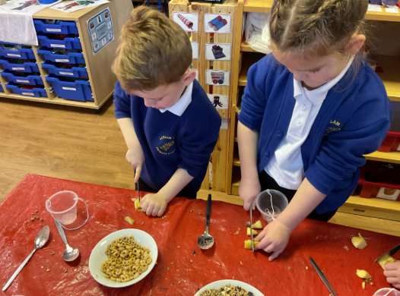
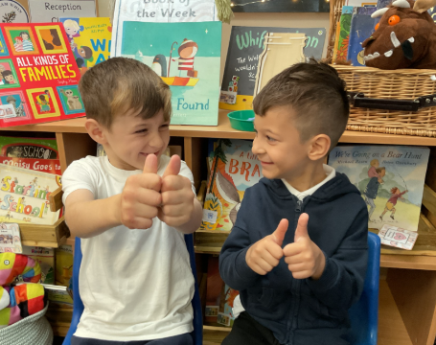
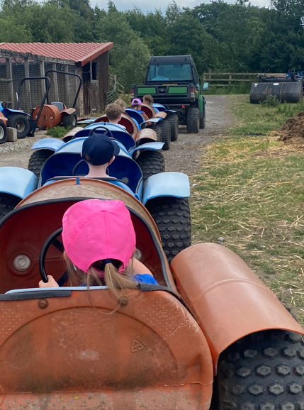
2026 - 2027

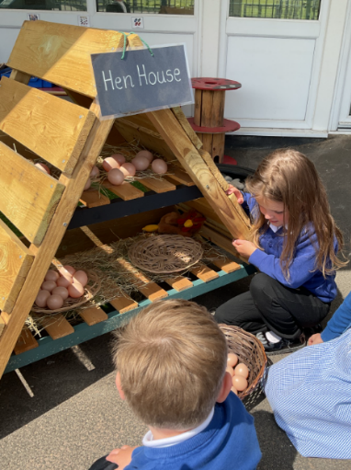
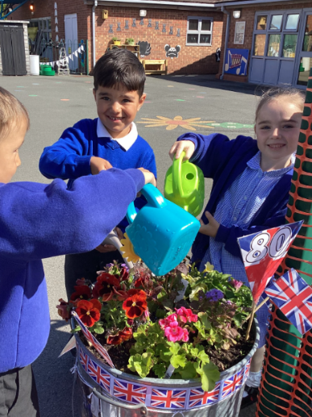

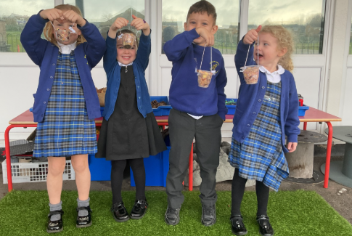

School Contact Details

Acklam Whin Primary School
Carlbury Avenue
Acklam
Middlesbrough
TS5 8SQ

Main telephone contact number: 01642 813938
Email: awcontact@acklamwhin.co.uk
Website: www.acklamwhin.co.uk

Follow us on Twitter (X): @acklamwhin
Like us on Facebook: Acklam Whin Primary

Contents
Page Number
Welcome 3
Our School Aims, Vision and Values 3
Staffing 2026/2027 4
Preparing Your Child for School 5
School Uniform 6
Classroom Organisation 7
The Reception Environment 8
Starting Reception 9
Pupil Information 10
Attendance 10
Medicines in School 11
Snack Time 11
Lunch Time 11
Early Years Foundation Stage (EYFS) Curriculum 12
Parent Partnerships 14
Special Educational Needs and Disabilities (SEND) 14
Foundations of Behaviour 15
Parental Engagement 15
Wrap around Care 15
Further Information 15

Welcome

A very warm welcome to Reception at Acklam Whin Primary School.

We know that starting school is a significant and special milestone and we look forward to getting to know your child and your family.

Our School Aims, Vision and Values
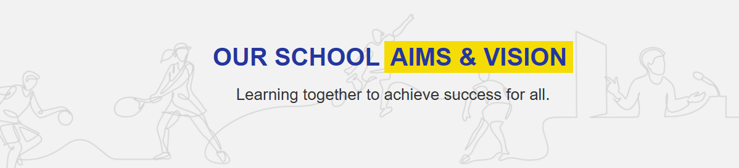

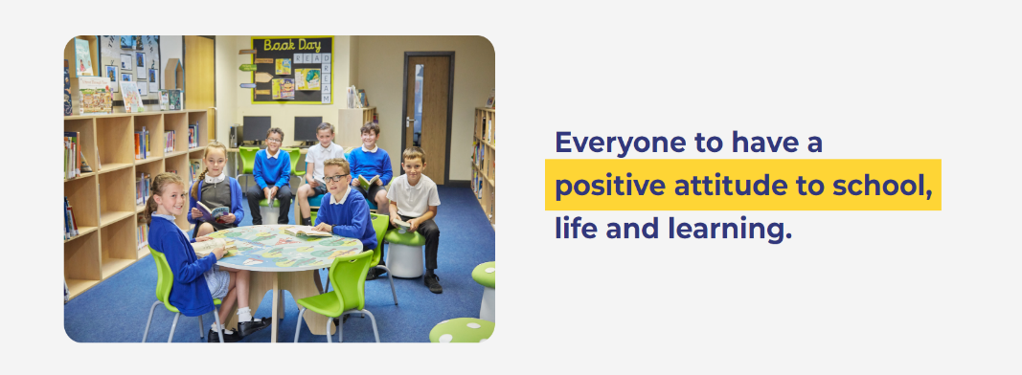
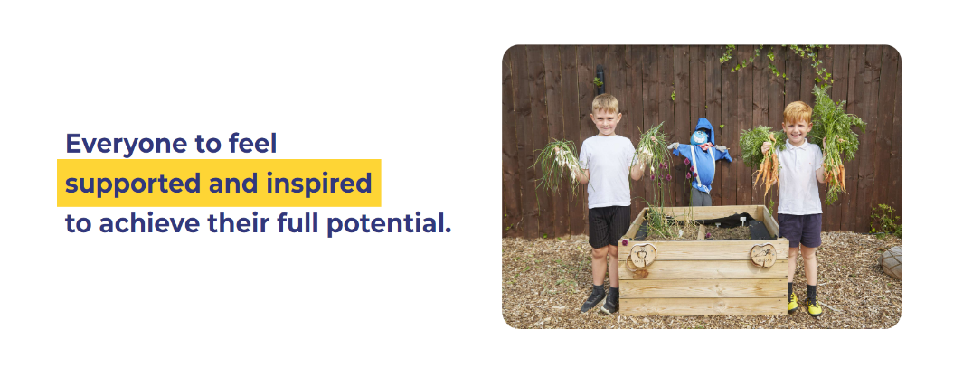
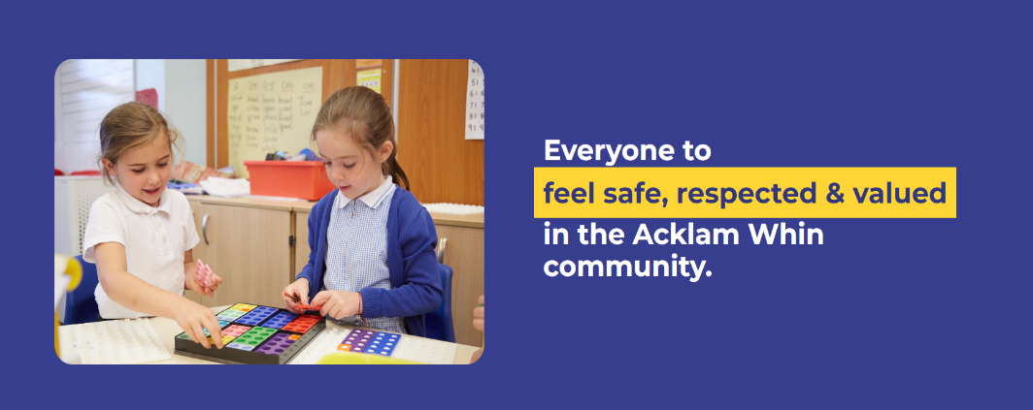

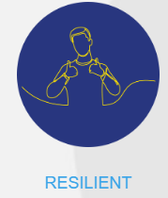
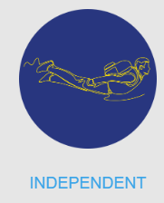
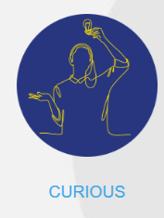
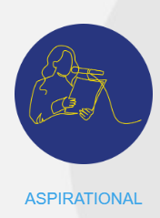
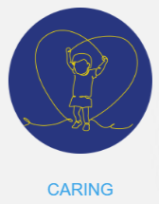

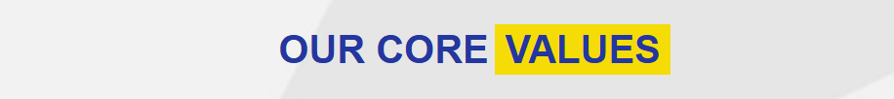
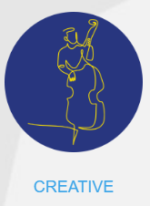

Staffing 2026/2027

Senior Leaders

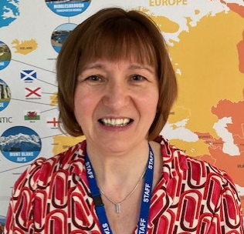
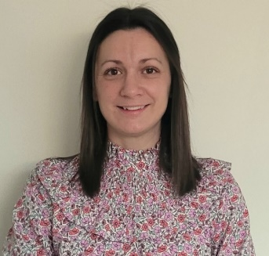
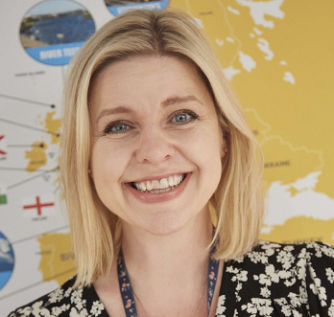

Miss Tarran
Deputy Head Teacher
SENDCo
Designated Safeguarding Lead

Mrs Prince
Head Teacher
Mrs Wilson
Assistant Head Teacher

Our Reception Team
In Reception your child will be taught and cared for by the Reception team, who will deliver all aspects of the Foundation Stage curriculum. All children are taught PE by our Sports Coach Mr Jackson.

Below you will find photographs of the Reception Team, which we hope will assist you in getting to know us quickly.
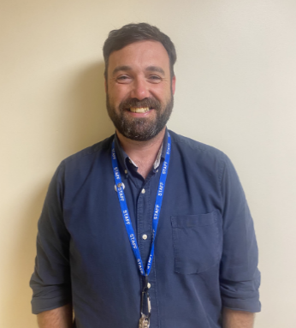
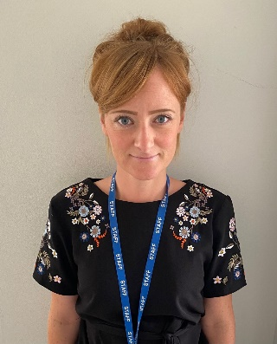

Miss Mills
Early Years Lead and Reception Teacher

Mr Armstrong
Reception Teacher

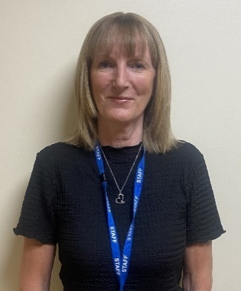
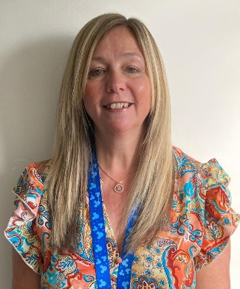
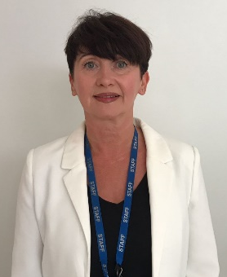

Mrs Small
Teaching Assistant

Mrs Hamilton
Teaching Assistant

Mrs McCarten
Teaching Assistant

You can contact the Reception teachers with any queries you may have by contacting the School Office via email at
awcontact@acklamwhin.co.uk
Preparing your Child for School
Your child will have lots of new activities and routines to get used to when they start school. There are some things they’ll need to do more independently than they might have before. The skills below are essential foundations for a confident start to Reception. Some of these skills take time to master, so it’s good to introduce them gradually in your daily routine. Please support and encourage your child to practise these skills at home.

Growing Independence
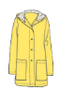

Taking care of themselves
- Putting on/taking off their coat and shoes
- Using the toilet and washing their hands
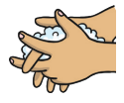
- Getting dressed with little help, e.g. after using the toilet or doing PE
- Using cutlery (e.g. fork and spoon, chopsticks) and drinking from an open cup
- Spending time away from you, learning they can be looked after by caring adults
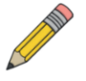
Play, creativity and curiosity
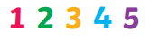
- Taking part in imaginative play (e.g. role play)
- Drawing, painting, colouring and sticking
- Counting, building and doing puzzles
- Exploring the world around them (e.g. looking closely at the natural world, noticing numbers, patterns and shapes, playing safely with objects at home)
Building relationships and communicating
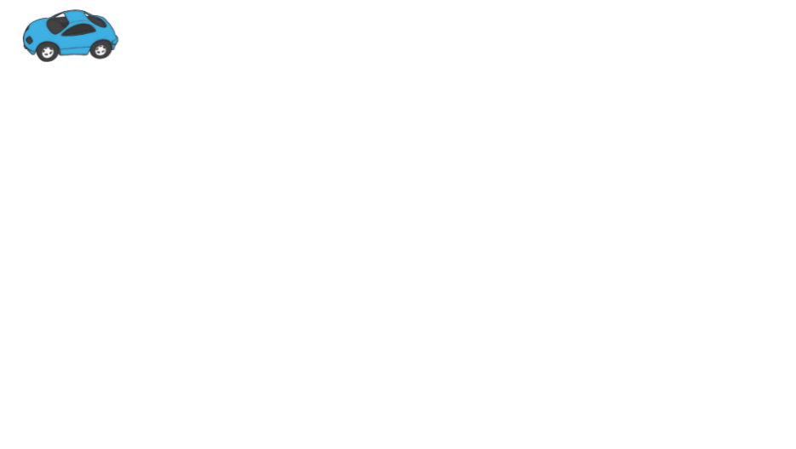
Being with others
- Practising sharing and taking turns with toys
- Talking to them about how they are feeling and why
- Looking at story books together and speaking about what characters are feeling is a good way to do this
- Beginning to recognise what others are feeling, e.g. understanding if a friend is sad
- Encouraging them to set boundaries for themselves and others (e.g. knowing how to say ‘no’)

Communication and language
- Singing along with songs and nursery rhymes
- Talking happily to others about activities, experiences and the world around them
- Showing they need help by speaking clearly
- Recognising the pattern of their name (so they can find it on their uniform, peg, book bag)
Listening and engaging
- Paying attention for short periods of time
- Listening to and following simple instructions
- Carrying on with a task even when it’s difficult and bouncing back if things go wrong
Physical development
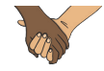
Getting moving for at least three hours a day
- Walking up and down steps (one foot at a time, using the wall for support)

- Climbing, running, jumping and playing
- Catching a large ball (most of the time)
- Doing simple puzzles and craft activities, strengthening their grip with cutting and sticking
Healthy routines
- Going to bed around the same time each night, waking up in time to get ready for school
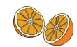
- Limiting screen time to the recommended daily amounts
- Eating a healthy diet and trying new foods
- Brushing their teeth with fluoride toothpaste twice a day

For further details about school readiness, please refer to the attached Starting Reception document.

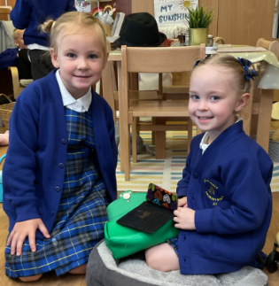
School Uniform

- Royal blue school logo jumper or cardigan
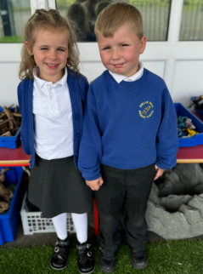
- White shirt or polo shirt
- Acklam Whin tartan pinafore/skirt
- Grey trousers/skirt/pinafore
- Grey, black or white socks
- Grey or black tights
For summer months:
- Grey shorts
- Blue and white gingham summer dress

Footwear – plain black shoes (not boots) should be worn at all times in school. Trainers will not be permitted unless in exceptional circumstances and agreed with school.
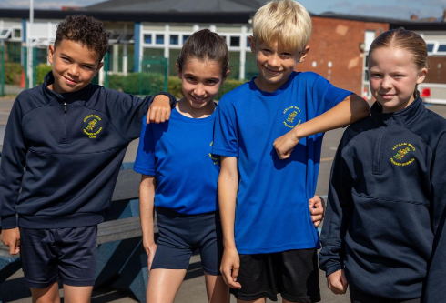
The P.E. Kit for Acklam Whin is as follows:
- Blue school logo Cool P.E. T-shirt
- Navy school logo ¼ zip P.E. top
- Navy shorts
- Navy plain joggers/leggings
- School sweatshirt/jumper/cardigan
- Black or white plain trainers

Please note, football kits, hoodies and branded sportswear are not permitted.

Some items of pre-loved uniform are available from the school office at a cost of £2 per item.

Reception PE Days are Mondays and Wednesdays - on these days, children are to attend school in their PE Uniform and remain in it for the whole day.

Our EYFS curriculum involves exploring and investigating the outdoor environment. We use the outdoor area every day, so we ask that your child wears a warm waterproof coat and a hat during the winter. In summer, please provide a sun hat/cap for protection and apply sun cream before coming to school.

Please ensure that all items of uniform are clearly named.

Jewellery
The school rules on jewellery are as follows:
• One pair of small stud earrings may be worn.
• No other jewellery to be worn.
• All earrings must be covered or removed at home on Reception P.E days.

Make-up and hair
Children are not permitted to wear make-up to school, this includes the wearing of nail varnish and transfers/temporary tattoos. Patterns in children’s hair or unusual colours are not in line with our high expectations and are not permitted. Hair accessories, bobbles, slides and bows should be in the school colours and of a reasonable size.

To order school uniform or items with the school logo on please go to the following website.
Lollipop Uniform

The Early Years curriculum encourages children to be creative and explore – this can sometimes be messy! Please be aware that uniforms may get dirty and may need to be washed and replaced more regularly

Book Bags
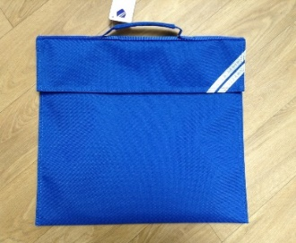
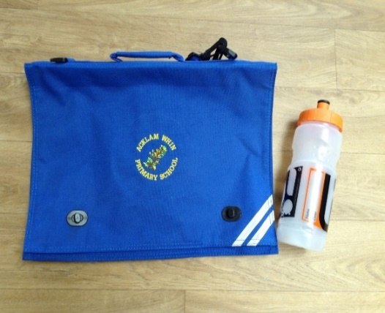
Children will be given an Acklam Whin book bag, this must be brought into school every day. Children keep their book bags in a tray inside the classroom. Book bags should be checked daily and kept tidy.

Rucksacks or any other bags are not necessary and should not be brought into school as they do not fit in children’s trays or coat pegs

Water Bottles

Children will be given a water bottle, this must be brought into school every day. Bottles must contain water only; flavoured water or juice are not allowed. Water bottles will be named and kept in the classroom. Children will be encouraged to drink regularly during the school day. Bottles will be sent home at the end of each day to be washed and refilled.

Replacement water bottles can be purchased from the School Office.

Personal Belongings

Toys or other ‘valuable’ possessions should not be brought into school as their safe keeping cannot be guaranteed and the loss of such precious belongings can cause distress to their owners.

Classroom Organisation

- We have two classes in Reception each with approximately 30 children.
- Classes and class teachers will be allocated following an initial settling in period.
- A number of factors are considered when deciding which class, a child is placed in, such as, birthdays, gender, friendships, personalities etc.
- Provision areas and resources across the classrooms are set up to promote the seven areas of learning.
- Across the year the children will access both our indoor and outdoor curriculum.
- Children access both classrooms and the outdoor learning areas.
- Both classes spend break time and lunch time on the Reception playground/field together.
- Teaching assistants provide support across both classes.

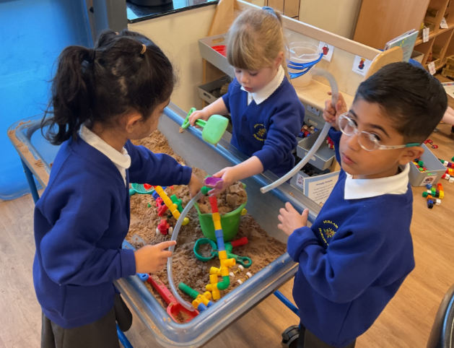
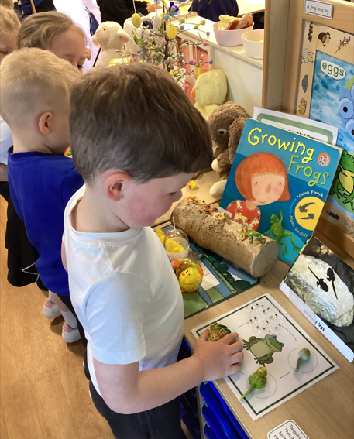
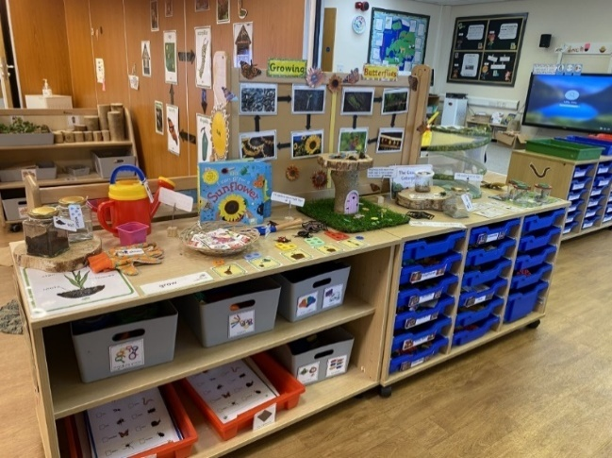

The Reception Environment
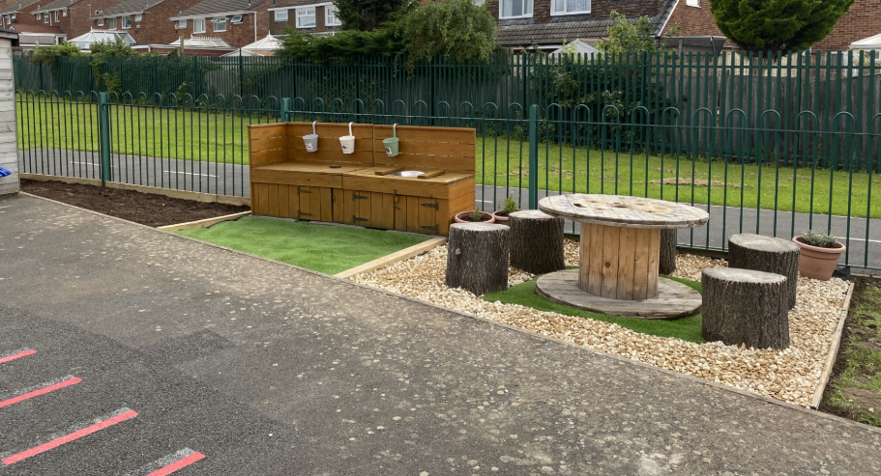
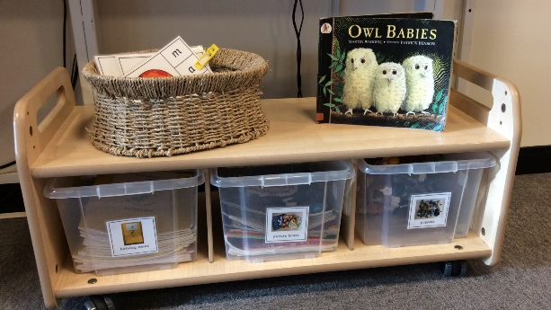
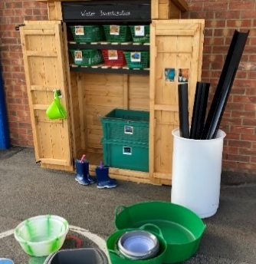
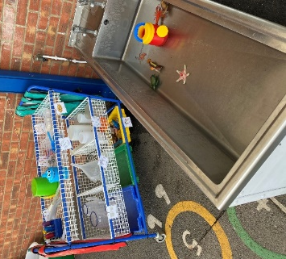
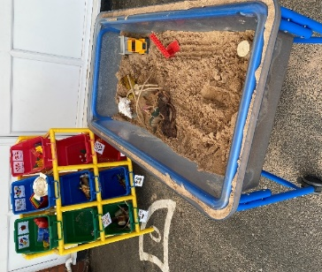
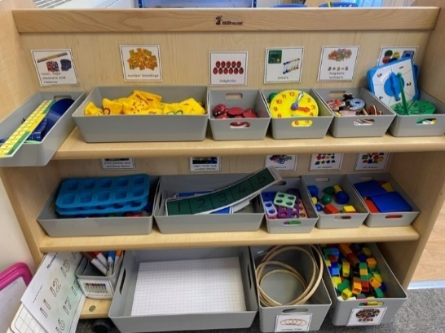
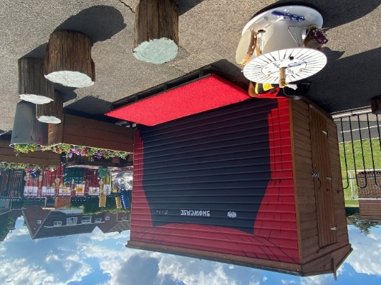
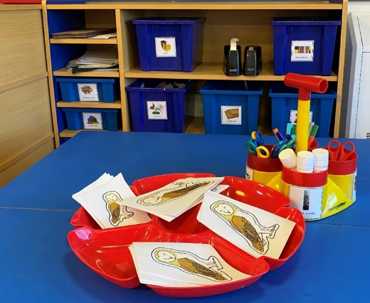
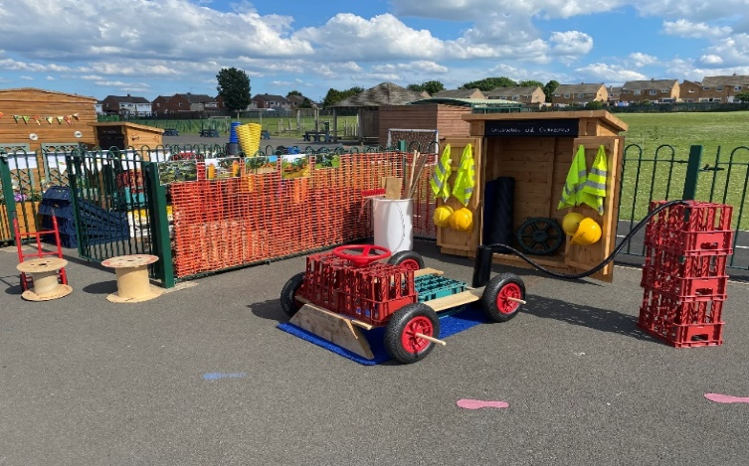
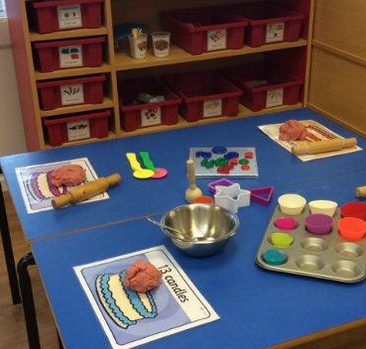
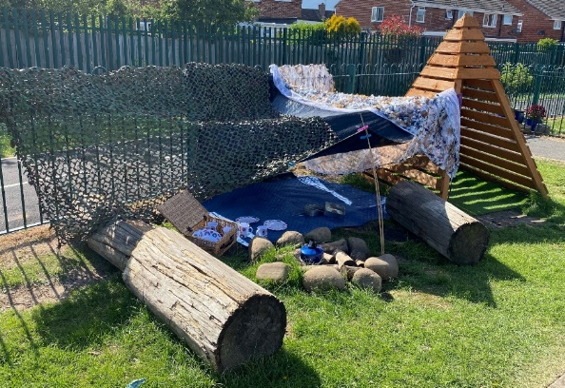
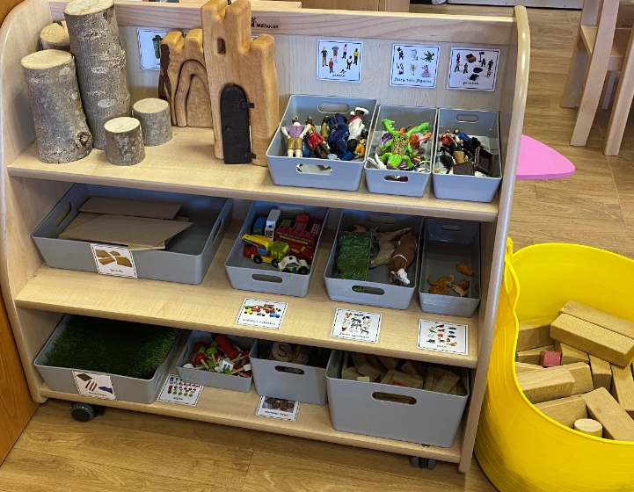
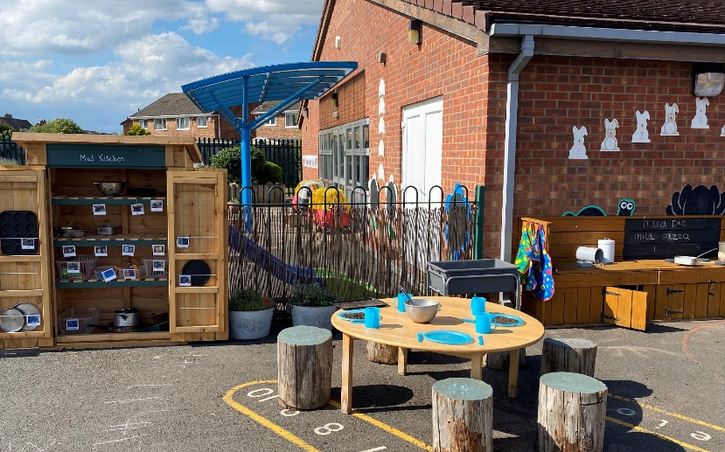
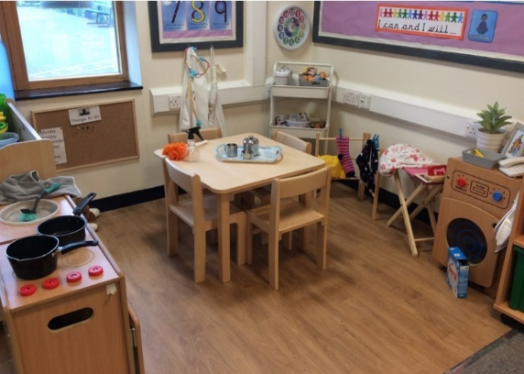
Starting Reception

Home Books
All children starting Reception in September will be given a ‘home book’ to complete during the Summer holidays. The home book is used during the staggered start to support transition and inform planning.

Parents are encouraged to help their children add information about things that are special to them, for example family, pets, favourite food etc. Home books are also sent home during the Christmas and Easter holidays for your child to record their news. These home books give us a lovely insight into our children’s families and the activities they enjoy as well as another opportunity for parents to share significant achievements in their development e.g. learning to ride a bike without stabilisers.

Staggered Starts
To help the children settle into their new environment, we have a staggered start across the first week of the autumn term. You will receive notification of your child’s start date in July. Due to limited space and to encourage independence we ask that children enter our Reception cloakroom by themselves. The Reception Team will be on hand to help children as they enter school.
Drop-off and Collection
To help keep our children and families safe please note the following:
- Children must be collected by a responsible person over the age of 16;
- Dogs are not allowed onto the school site;
- Acklam Whin Primary School is a non-smoking site;
- We ask that parents do not reprimand other children. Any problems must be brought to the attention of the school staff, who will endeavour to find a solution;
- As part of our Active Travel Policy we encourage children to walk, cycle or scooter to school. We have pods on the EYFS playground where children can store their bicycles/scooters during the school day. To prevent accidents, children must dismount their bicycles/scooters once on the school site.

Start of School Day
Good time-keeping is very important as starting school can be daunting for both children and parents. Please ensure you arrive promptly on the playground for the correct arrival time (8.40 am) and pick up time (3.15pm). If you are running late for any reason, please telephone the School Office.
Every morning, when the bell rings, the Reception Team will come out onto the playground to greet the children and escort them into school. Cones will be placed to indicate where children need to line up. Parents/Carers must remain on the playground with their children until they have been taken into the school building by the Reception Team.

Children are encouraged to enter the classrooms independently, put away their things and follow the morning routine. Each child has a personalised tray and coat peg to store their belongings. Once the Reception door is closed, late entry to school is through the School Office only. The school gates will be locked at 8.50am and remain so throughout the school day.
End of School Day
At home time the Reception Team release the children one at a time and only when they have seen their appropriate adult. Please keep us informed if a different adult is collecting your child. Please be patient at the beginning of the term as the staff get to know lots of new faces.

If a child is not collected at the end of the school day their teacher will contact parents or another appropriate adult from the contact numbers provided. The teacher or a staff member will remain with the child until they are collected. It is the parent’s/appropriate adult’s responsibility to collect the child as quickly as possible.

A Typical Day

8.40 am | Doors Open
8.50 am | Register/ Fine Motor Skills
9.00 am | Phonics
9.30am | Independent play in continuous provision areas (indoor and outdoor)  Handwriting
10.30 am | Snack time/singing/nursery rhymes
10.45am | Independent play in continuous provision areas (indoor and outdoor)  Reading
11.30 am | Story
11.45 am | Lunchtime
12.55 pm | Register
1.00 pm | Maths
1.30 pm | Independent play in continuous provision areas (indoor and outdoor) and adult led activities e.g. Literacy, Understanding the World or Expressive Art and Design.
2.50 pm | Story
3.15 pm | Home time

Pupil Information

The school is required to keep contact information for each child. At the start of the autumn term parents will be asked to complete a ‘Pupil Information form’ e.g. contact, medical/dietary information.

Please speak to the Reception staff about your child if there are any specific details you feel we need to know.
It is the parent’s responsibility to keep the school informed of any changes.
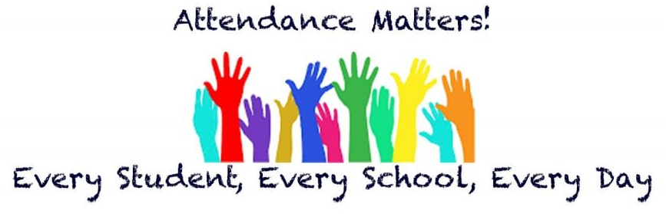
Attendance
From children entering Reception we encourage excellent attendance. The school is required to complete registers of children’s attendance every morning and afternoon and any absence has to be accounted for as either authorised or unauthorised.
Absence from School
Please contact the School Office, if possible before 9.00am, if your child is unwell or unable to attend school for any reason. If we haven’t heard from you, a member of the office staff will contact you on the first day of absence. Please ensure contact information is kept up to date at all times. If your child is unwell during the school day a member of staff will contact you.
48-hour rule
Diarrhoea and/or vomiting commonly affects children and staff and can be caused by a number of different germs, including viruses, parasites and bacteria. Infections can be easily spread from person to person (by unwashed hands) especially in children. In general, it is recommended that any child or staff member with diarrhoea and/or vomiting symptoms must stay away from school until they have been free of symptoms for 48 hours (the ’48-hour rule’) and feel well.
If your child is sick at school we will ask you or your emergency contact to collect your child and take them home. They should not return for 48 hours following the last episode of vomiting/diarrhoea. For example, if your child is sick on a lunchtime on Tuesday, they should not return to school until after lunch on Thursday, provided there have not been any further episodes of vomiting/ diarrhoea. We appreciate that this is inconvenient in many cases and you may believe that your child has recovered sooner, however, we must follow this procedure in all cases to reduce the risk of infection for all children in school.

Medical and Dental Appointments
Where possible please make appointments outside of school hours. However, if this cannot be avoided, please notify the School Office in advance.
Holidays and Leave of Absence
The Headteacher will not grant holidays or leave of absence during term time unless there are exceptional circumstances. Notification of Leave of Absence Forms are available from the office on request; however, completion of this form does not mean that the absence is authorised.
Medicines in School

In the event of your child needing to take medicine in school that has been prescribed by your doctor to be taken four times a day, this must be brought to school in the prescribed container from the pharmacy, with the pharmacy label attached, your child’s name, medication and dosage. This should be taken to the school office where you will be asked to fill in a consent form. Please do not send any medicine in your child’s book bag.
For further information please refer to the First Aid Policy on the school website.

Snack-time

The school provides daily fruit for the children at snack time. Please do not send your child to school with additional food items.

Lunchtime

School Meals
Children in Reception, Year 1 and Year 2 currently receive a free school meal. We would recommend that all children, when starting in Reception, have a school meal. There is a selection of hot meals and a salad bar to choose from. Children may make some unusual choices or might not always like what they choose but this usually settles down after the first few weeks. If your child is not eating their lunch on a regular basis the Reception staff will inform you of this. An example menu can be found on the school website.
All children are supported and supervised by our lunchtime supervisors when choosing their lunch and they are encouraged to eat and try most things. For the first few weeks, whilst the children are settling into routines, the Reception staff will stay in the Dining Hall with the children.
Packed Lunches
Children who do not take up the option of a school meal may bring a packed lunch. Please ensure their lunch box is named and a healthy balance of foods is provided. Please try not to overfill your child’s packed lunch. Nuts, glass flasks, cans or fizzy drinks are not permitted.

If you would like your child to change from a packed lunch to a school meal you will need to inform the staff in the School Office, giving one week’s notice.
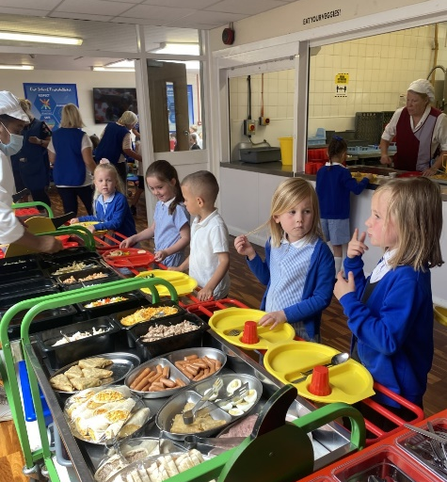
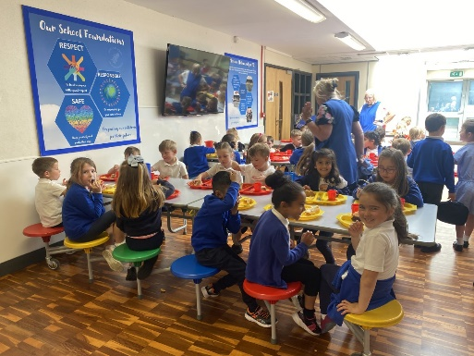
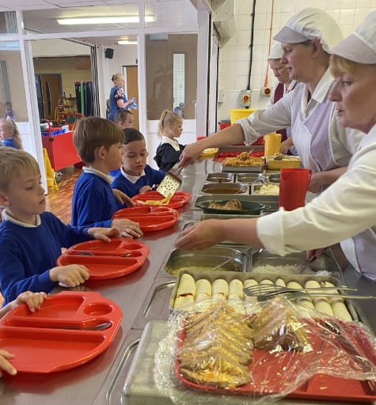
Early Years Foundation Stage (EYFS) Curriculum

Our Reception curriculum is designed to meet the needs of our children through activities that are meaningful, ambitious, practical and experiential. Children will be learning through well-planned play which is an essential part of the EYFS curriculum. Children will be given opportunities to work under teacher direction and independently around the classrooms. Our staff plan together, taking into account children’s individual starting points, to design a curriculum which offers continuity and progression.

How we learn:
There are three characteristics of effective teaching and learning which underpin how children learn in our Reception environment.
- Playing and Exploring – we encourage children to investigate and experience things, and ‘have a go’.
- Creating and Thinking Critically – we encourage children to have and develop their own ideas, make links between ideas, and develop strategies for doing things.
- Active Learning – we encourage children to concentrate and keep on trying if they encounter difficulties. We enjoy and celebrate their achievements.

What we learn:
There are seven areas of learning within the EYFS curriculum which are all interconnected. The seven areas of learning encompass the full range of emergent skills and aid development towards all of the subject areas which form part of the National Curriculum which the children will follow from Year 1. We ensure that each child works at a level appropriate to their needs and abilities.
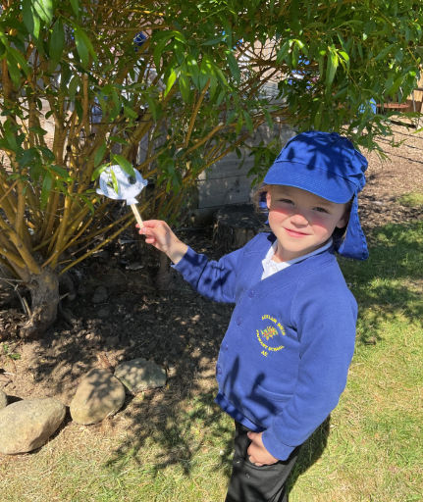
Seven Areas of Learning:
Three Prime Areas
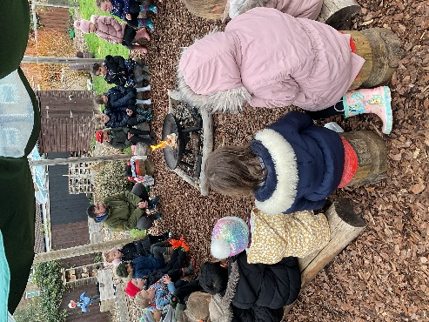
Communication and Language Development:
- Listening, Attention and Understanding
- Speaking
Personal, Social and Emotional Development:
- Self-Regulation
- Managing Self
- Building Relationships
Physical Development:
- Gross Motor Skills
- Fine Motor Skills

Communication and Language Development
We provide opportunities to experience a rich language environment to develop children’s confidence and skills in expressing themselves and to speak and listen in a range of situations; including conversations, story-telling and role play to develop a rich range of vocabulary and language structures.

Personal, Social and Emotional Development
We help children to develop a positive sense of self, set themselves simple goals and have confidence in their own abilities. Children will learn to look after their bodies including healthy eating and managing personal needs independently. Children will learn how to make good friendships, co-operate and resolve conflicts peacefully.

Physical Development
We provide opportunities for children to be active and interactive; and to develop their core strength, co-ordination, stability, balance, spatial awareness and agility. Children will be helped to understand the importance of physical activity and to make heathy choices in relation to food.

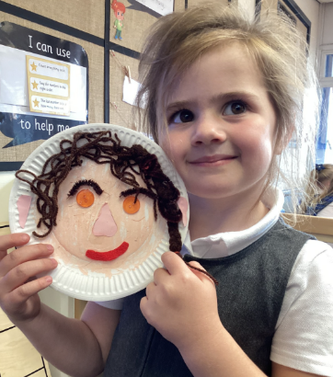
Four Specific Areas
Literacy:
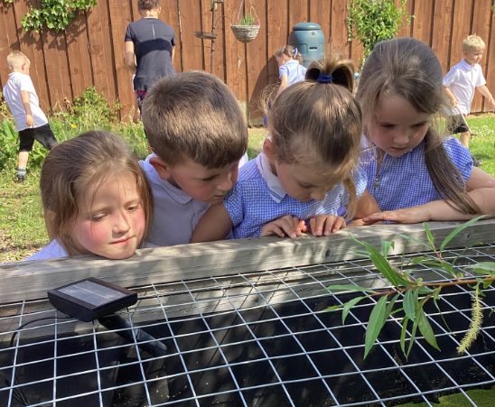
- Comprehension
- Word Reading
- Writing
Mathematics:
- Number
- Numerical Patterns
Understanding the World:
- Past and Present
- People, Culture and Communities
- The Natural World
Expressive Arts and Design:
- Creating with Materials
- Being Imaginative and Expressive

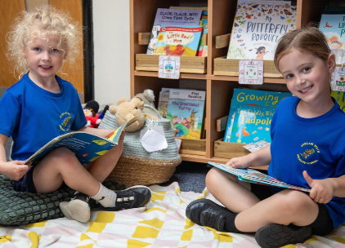
Literacy
We nurture a life-long love of reading by engaging children in conversations about the world around them and the books, rhymes, and songs they enjoy. We support both the speedy decoding and pronunciation of unfamiliar words and the quick recognition of familiar printed words. The sounds they have learnt are applied to spell words accurately in their writing. We also place a strong emphasis on developing handwriting skills, encouraging children to form letters correctly and write with increasing control and fluency.

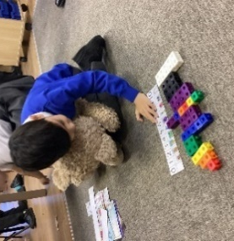
Mathematics
We provide children with opportunities to count confidently, develop a deep understanding of the numbers to 10 and understand the relationships between them and the patterns within those numbers. Children will also learn early ideas relating to shape, space and measure.

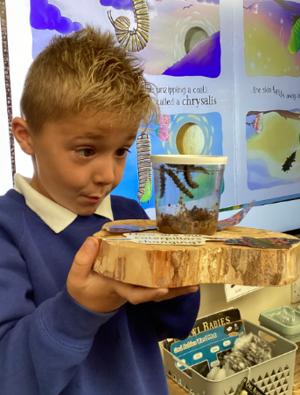
Understanding the World
We guide children to make sense of the physical world and the community around them through opportunities to explore, observe and find out about our culturally, socially, technologically and ecologically diverse world.

Expressive Arts and Design
We provide a wide range of media and materials for children to explore and play with, as well as opportunities and encouragement for sharing thoughts, ideas and feelings through a variety of activities in art, music, movement, dance, role-play and design and technology.

Curriculum Themes:
The seven areas of learning are delivered through a stimulating and engaging curriculum. Half termly curriculum overviews are shared with parents via Seesaw and displayed on the school website. These overviews explain our weekly themes, suggestions on how to support your child at home and key vocabulary to use when talking to them.

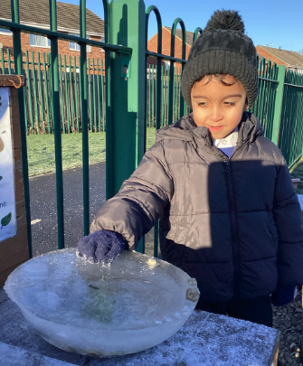
Homework:
The very best way to support your child at home is to provide a language rich environment. Spend as much time as you can talking, listening, singing songs and nursery rhymes and sharing stories every day. Ask questions and encourage your child to have conversations. Technology has become a vital part of our everyday life and has many benefits; however, for young children, access to iPads, tablets, phones etc. should be carefully monitored and limited. Technology cannot replace the intimacy and benefits of a bedtime story!

Initially children will bring home a shared picture book from our school library. The shared picture books are for you to read to your child. When they are ready children will be given a decodable reading book. These books match the sounds they have been taught in school and will support them to build and blend simple words and sentences in addition to supporting them to recognise common high-frequency words. Alongside our decodable books, children will bring home game pages, sound cards and high-frequency words to further support their learning.

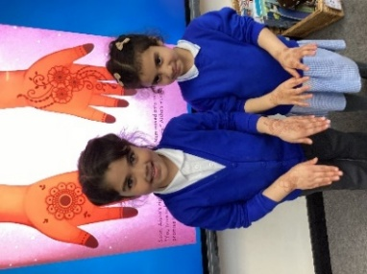
Life experiences are very important and make a huge difference to children’s development. We encourage you to spend time outdoors and enjoy sharing experiences of the wider world together, such as:
- Going to the beach to collect shells and paddling in the sea;
- Visiting the farm to get to know the animals;
- Going on a forest walk, to collect leaves, twigs and conkers;
- Helping in the garden, planting seeds and watching new life grow;
- Going to the supermarket, finding items off a shopping list and helping to put them away.

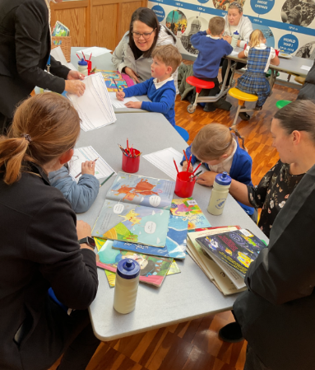
Parent Partnerships

As part of our EYFS assessment we invite you to share any achievements or activities completed outside of school that will contribute to us building an overall picture of your child’s progress and development whilst they are in Reception.

Parent consultation evenings take place termly. Consultations provide an opportunity for parents to talk to the class teacher about their child’s development and progress. A written report summarising development and progress is provided at the end of the summer term. Reception has an open-door policy and staff welcome opportunities to discuss and share news from home and respond to parental questions or concerns.

Special Educational Needs and Disabilities (SEND)

Miss Tarran is our designated SENDCo and together with your child’s class teacher can support you with any concerns regarding:
- Communication and Interaction;
- Cognition and Learning;
- Social, Emotional and Health Difficulties;
- Sensory and/or Physical Difficulties.
Should you wish to contact Miss Tarran, please contact the School Office.
More information on our policies and procedures for how we identify and support children with SEND can be found on our website www.acklamwhin.co.uk

Mrs Tribe is our Emotional Literacy Support Assistant (ELSA) and is available to support children with emotional needs.

Foundations of Behaviour
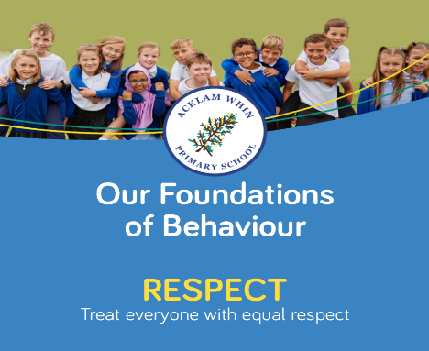
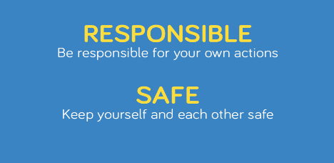
We aim to create a welcoming, caring environment, where relationships are based on respect. We encourage children to develop a positive sense of self-esteem in which every child can thrive.

Parental Engagement

We have a number of ways in which we engage with our parents:
- Curriculum parent/child sessions
- Acklam Whin Primary School App – the Parentapps Connect system provides you with instant access to our calendar, event information, letters home and class pages. It also links directly to our website from within the App.
- The school website – www.acklamwhin.co.uk – provides key information about school and policies.
- Seesaw App – provides you with access to our half termly curriculum overviews, notifications about classroom activities/events and a platform to share achievements or activities completed outside of school.
- Twitter (X) - @acklamwhin
- Facebook – like us at Acklam Whin Primary.

As well as our website, social media and school apps we will also keep in contact with you through:
- Our Reception noticeboard which is situated on the Reception playground
- Curriculum information meetings
- Termly parent consultations

Wrap around Care

Parkway Day Nursery, based on the Acklam Whin Primary School site, offers breakfast and after-school care for our pupils. The Reception Team works closely with the Parkway Staff to ensure care is consistent in all areas.
For further information please contact Rachel Jones, Parkway Day Nursery, on 01642 577316

Further information
We hope that you find the information within this handbook useful. If you have any queries now or in the future we are happy to help. You will find lots more information by exploring our school website www.acklamwhin.co.uk

